**Image Processing using Parallel programming**

**Introduction:**

Our project will be about using parallel computing to speed up applying an average filter in image processing.

1. we will broadcast the filter array to all processors.

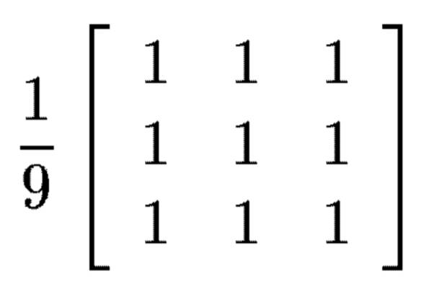

2.Divide the image equally among all processors.

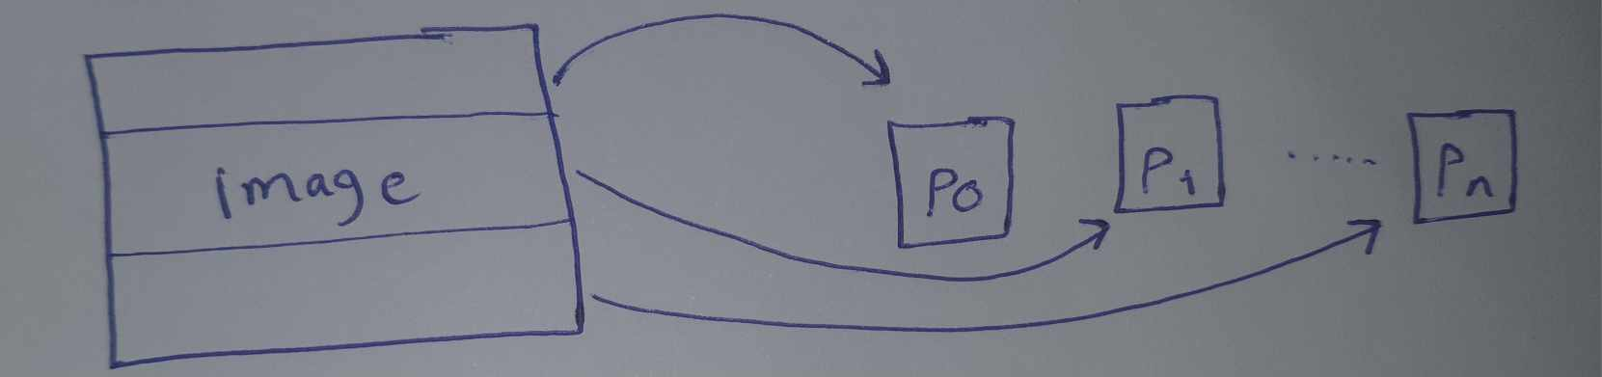

3.Each processor will apply the filter on its own part of the image.

4.All processors will the send their parts of the image after applying the filter to the master.

5.The master processor will assemble all processed parts into one complete image.

**A) Using MPI Library:**

Process 0 initializes MPI then Process 0 partitions the data array among processors by scattering the data array through MPI send operations. Each processor receives its segment of the data array from process 0 by MPI receive and stores it into recv_data array. After this each processor, including process 0, applies the average filter on its portion of the data array. then each processor transmits its filtered portion of recv_data array back to process 0 and are stored into data_filterd array. Once all filtered data is gathered, process 0 showcases the original matrix and the filtered matrix after applying the filter, displaying the before-and-after effects of the filter, as described in the following steps.

* Process 0 divides the matrix among processors by scattering the data array using MPI send
* Each processes receives its portion of the data array from process 0 using MPI receive and stores it into recv_data array then perform filtering on the received portion of the data array including process 0
* Each processes sends its filtered data to process 0
* Process 0 gathers the filtered data from all processes and stores it into data_filterd array
* Process 0 displays the data array and the new data_filterd array after applying filter

**The Code of MPI:**

#include<stdio.h>

#include<mpi.h>

#include<math.h>

#define maxsize_row 50

#define maxsize_col 10

/*double array_copy[maxsize_row][maxsize_col]={{1,2,3},{4,5,6},{7,8,9},{10,11,12},{13,14,15},{16,17,18},{19,20,21},{22,23,24},{1,2,3},{4,5,6},{7,8,9},{10,11,12},{13,14,15},{16,17,18},{19,20,21},{22,23,24},{1,2,3},{4,5,6},{7,8,9},{10,11,12},{13,14,15},{16,17,18},{19,20,21},{22,23,24}};//here the image in array_copy*/

double filter_average[3][3]={{0.11,0.11,0.11},{0.11,0.11,0.11},{0.11,0.11,0.11}};

int c=1;

void fill_Matrix(double m[maxsize_row][maxsize_col])

{

for (int i = 0; i < maxsize_row; i++)

{

for (int j = 0; j < maxsize_col; j++)

{

m[i][j] =c;

c++;

}

}

}

void print_Matrix(double m[maxsize_row][maxsize_col])

{

for(int a=0;a<maxsize_row;a++)

{

//printf("row number %d:",a);

for(int b=0;b<maxsize_col;b++)

printf("%f ",m[a][b]);

printf("\n");

}

}

//+++++++++++++++++++++++++++++++++++++++++++++++++++++++++++++++++++++++++++++++++++++++++++++

void main(int argc,char **argv)

{

int id,nop;

MPI_Init(&argc,&argv);

MPI_Comm_size(MPI_COMM_WORLD,&nop);

MPI_Comm_rank(MPI_COMM_WORLD,&id);

MPI_Status status;

int x=(maxsize_row-2)/nop;

int rest=(maxsize_row-2) % nop;

double data[maxsize_row][maxsize_col];

double data_filterd[maxsize_row][maxsize_col];

double local_data[x+rest+2][maxsize_col];

double local_data_filterd[x+rest+2][maxsize_col];

if(id==0){ // the root is p0

fill_Matrix(data);

int count=1;

//-----------------------------------------------------------------------------------------

// scatter the data to all p exept p0 by send&recv

for(int i=1;i<nop;i++)

{

for(int j=0;j<x;j++)

{

if(j==0)

MPI_Send(&data[count-1],maxsize_col,MPI_DOUBLE,i,1,MPI_COMM_WORLD);

MPI_Send(&data[count],maxsize_col,MPI_DOUBLE,i,1,MPI_COMM_WORLD);

if(j==x-1)

MPI_Send(&data[count+1],maxsize_col,MPI_DOUBLE,i,1,MPI_COMM_WORLD);

count++;

}

}

//---------------------------------------------------------------------------------------------

// scatter data to p0

int local_count=0;

for(int i=count-1;i<maxsize_row;i++)

{

for(int j=0;j<maxsize_col;j++)

local_data[local_count][j]=data[i][j];

local_count++;

}

//-------------------------------------------------------------------------------------------

// start filter on p0 (local data)

for (int i = 0; i < x+2+rest; i++)

{

for (int j = 0; j < maxsize_col; j++)

{

local_data_filterd[i][j] =local_data[i][j] ;

}

}

for(int a=1;a<x+1+rest;a++)

for(int b=1;b<maxsize_col-1;b++)

{

local_data_filterd[a][b]=(local_data[a-1][b-1]*filter_average[0][0]) + (local_data[a-1][b]*filter_average[0][1]) + (local_data[a-1][b+1]*filter_average[0][2]) + (local_data[a][b-1]*filter_average[1][0]) +(local_data[a][b]*filter_average[1][1]) + (local_data[a][b+1]*filter_average[1][2]) + (local_data[a+1][b-1]*filter_average[2][0]) + (local_data[a+1][b]*filter_average[2][1]) + (local_data[a+1][b+1]*filter_average[2][2]);

}

//-------------------------------------------------------------------------------------------

// gathering the data filterd from all processes by send/recv

int countReturnData=0;

for(int np=1;np<nop;np++)

{

if(np!=1)

for(int r=0;r<x;r++)

{

MPI_Recv(&data_filterd[countReturnData],maxsize_col,MPI_DOUBLE,np,1,MPI_COMM_WORLD,&status);

countReturnData++;

}

else

for(int r=0;r<x+1;r++)

{

MPI_Recv(&data_filterd[countReturnData],maxsize_col,MPI_DOUBLE,np,1,MPI_COMM_WORLD,&status);

countReturnData++;

}

}

//-------------------------------------------------------------------------------------------

// gathering the data filterd from p0 by into data_filterd

int local_count2=1;

for(int ii=countReturnData;ii<maxsize_row;ii++)

{

for(int j=0;j<maxsize_col;j++)

data_filterd[ii][j]=local_data_filterd[local_count2][j];

local_count2++;

}

}

//=============================================================================================

// other p

//=============================================================================================

if(id!=0)

{

int rcount=0;

double recv_data[x+2][maxsize_col];

double recv_data_filterd[x+2][maxsize_col];

//---------------------------------------------------------------------------------------------

// recv the scattering data into (recv_data)

for(int j=0;j<x+2;j++)

{

MPI_Recv(&recv_data[rcount],maxsize_col,MPI_DOUBLE,0,1,MPI_COMM_WORLD,&status);

rcount++;

}

//---------------------------------------------------------------------------------------------

// start filtering on recv_data

for (int i = 0; i < x+2; i++)

{

for (int j = 0; j < maxsize_col; j++)

{

recv_data_filterd[i][j] =recv_data[i][j] ;

}

}

for(int a=1;a<x+1;a++)

for(int b=1;b<maxsize_col-1;b++)

{

recv_data_filterd[a][b]=(recv_data[a-1][b-1]*filter_average[0][0]) + (recv_data[a-1][b]*filter_average[0][1]) + (recv_data[a-1][b+1]*filter_average[0][2]) + (recv_data[a][b-1]*filter_average[1][0]) +(recv_data[a][b]*filter_average[1][1]) + (recv_data[a][b+1]*filter_average[1][2]) + (recv_data[a+1][b-1]*filter_average[2][0]) + (recv_data[a+1][b]*filter_average[2][1]) + (recv_data[a+1][b+1]*filter_average[2][2]);

}

//------------------------------------------------------------------------------------------

// send the partion(after filterd) of evry process to p0

int scount=0;

if(id!=1)

{

scount=0;

for(int j=1;j<x+1;j++)

{

MPI_Send(&recv_data_filterd[j],maxsize_col,MPI_DOUBLE,0,1,MPI_COMM_WORLD);

scount++;

}

}

else

{

scount=0;

for(int j=0;j<x+1;j++)

{

MPI_Send(&recv_data_filterd[j],maxsize_col,MPI_DOUBLE,0,1,MPI_COMM_WORLD);

scount++;

}

}

/*printf("\n\nthe process is %d:\n",id);

for(int a=0;a<x+2;a++)

{

printf("the row %d are: ",a);

for(int b=0;b<maxsize_col;b++)

printf("%f ,",recv_data[a][b]);

printf("\n"); }

for(int a=0;a<x+2;a++)

{

printf("the row filterd %d are: ",a);

for(int b=0;b<maxsize_col;b++)

printf("%f ,",recv_data_filterd[a][b]);

printf("\n"); }*/

}

MPI_Barrier(MPI_COMM_WORLD);

//=============================================================================================

// show image befor and after the fitering

//=============================================================================================

if(id==0)

{

printf("\n\nthe original image (old image):\n");

print_Matrix(data);

printf("\n\nthe filterd image by average filter (new image):\n");

print_Matrix(data_filterd);

}

MPI_Finalize();

}

**Test Cases for MPI:**

1. Small matrix(10x10):

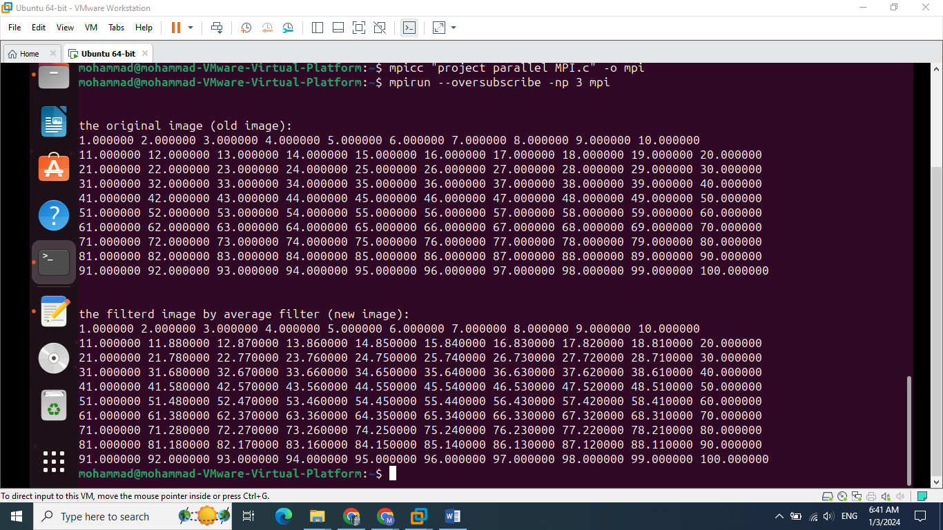

1. Medium matrix(50x10):

Input image:

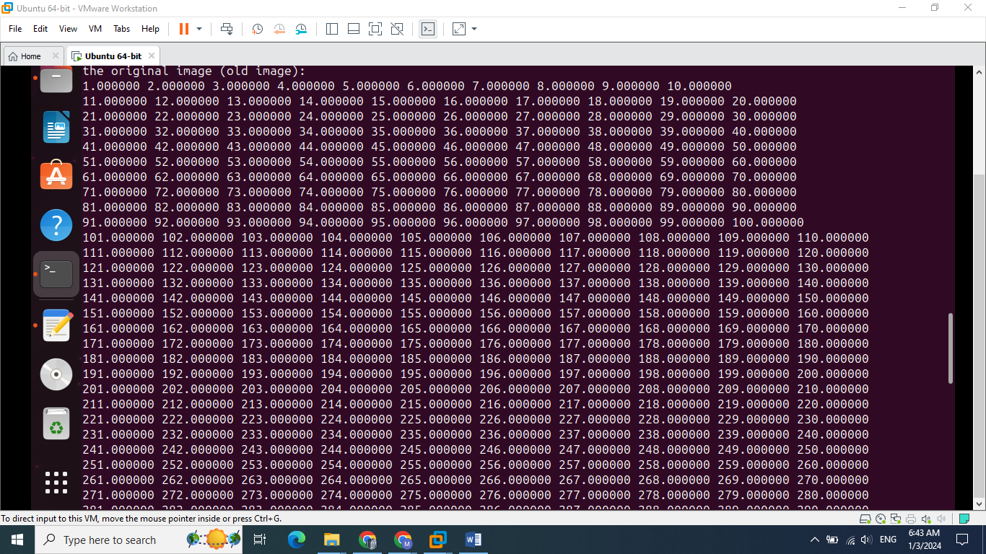

output image:

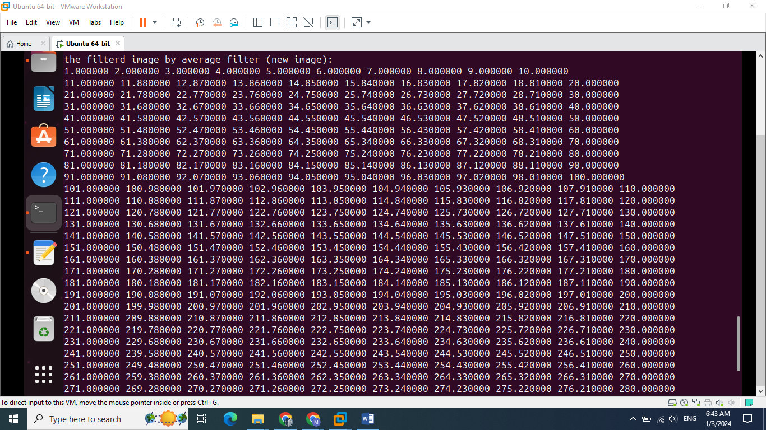

1. Big Matrix(100x10):

Input image:

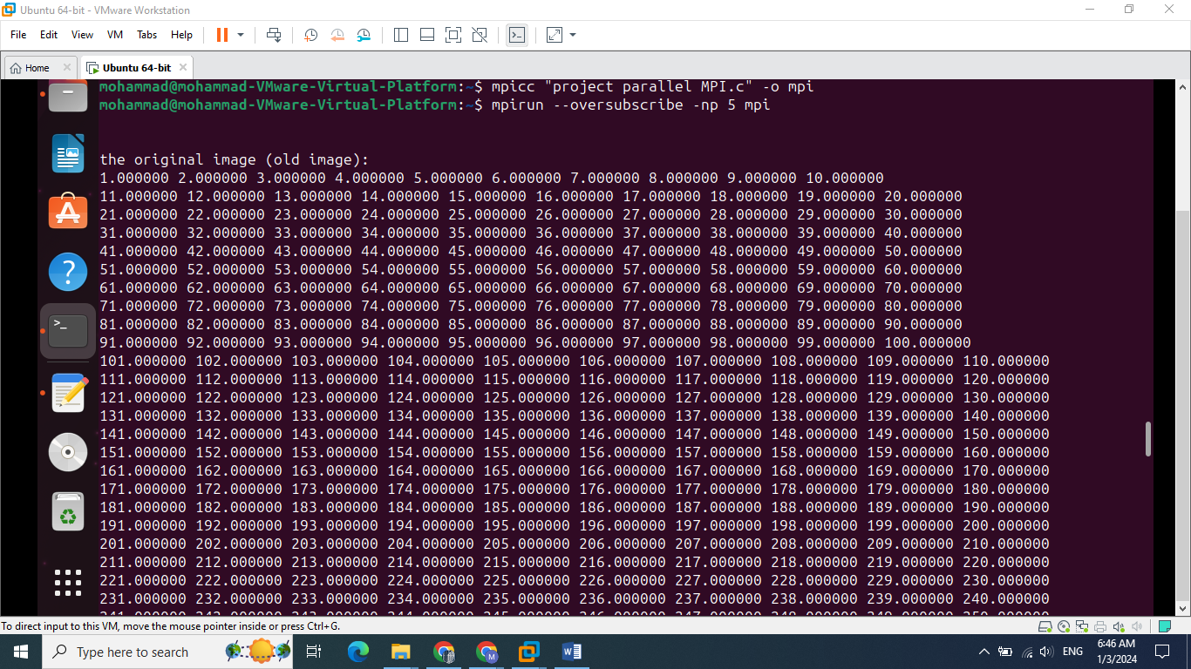

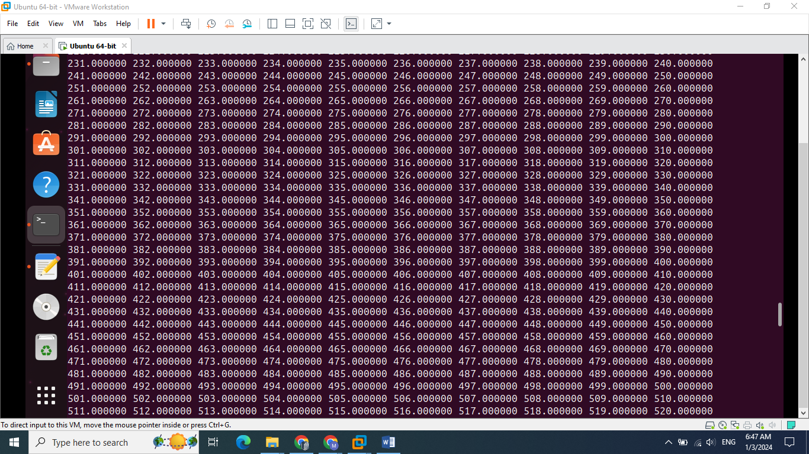

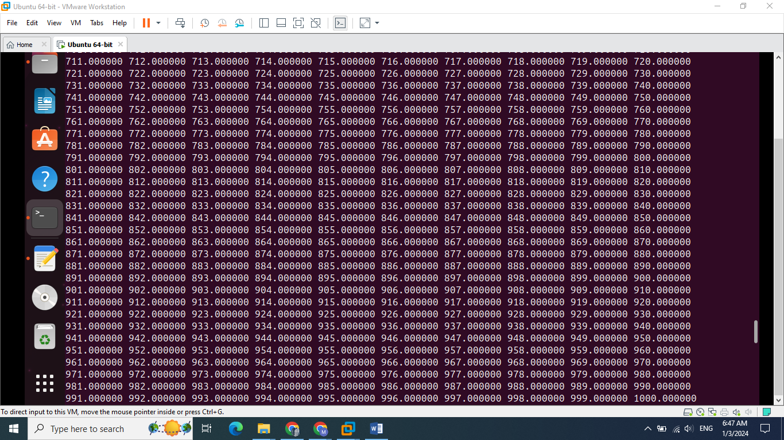

Output image:

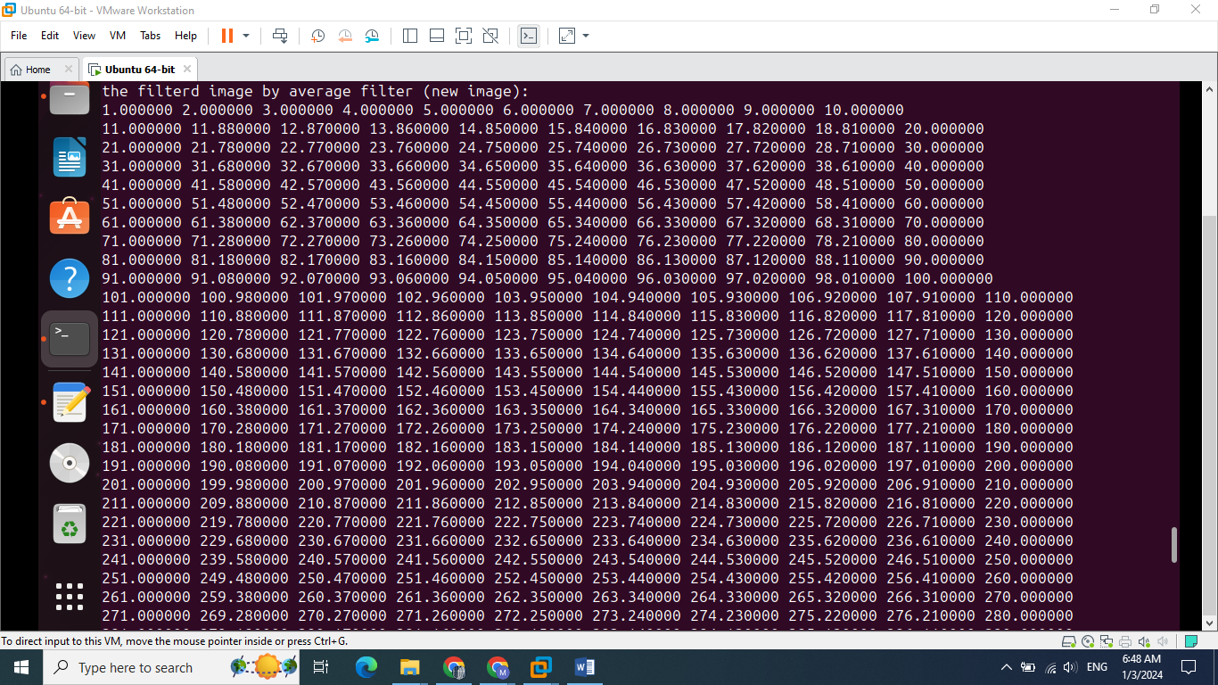

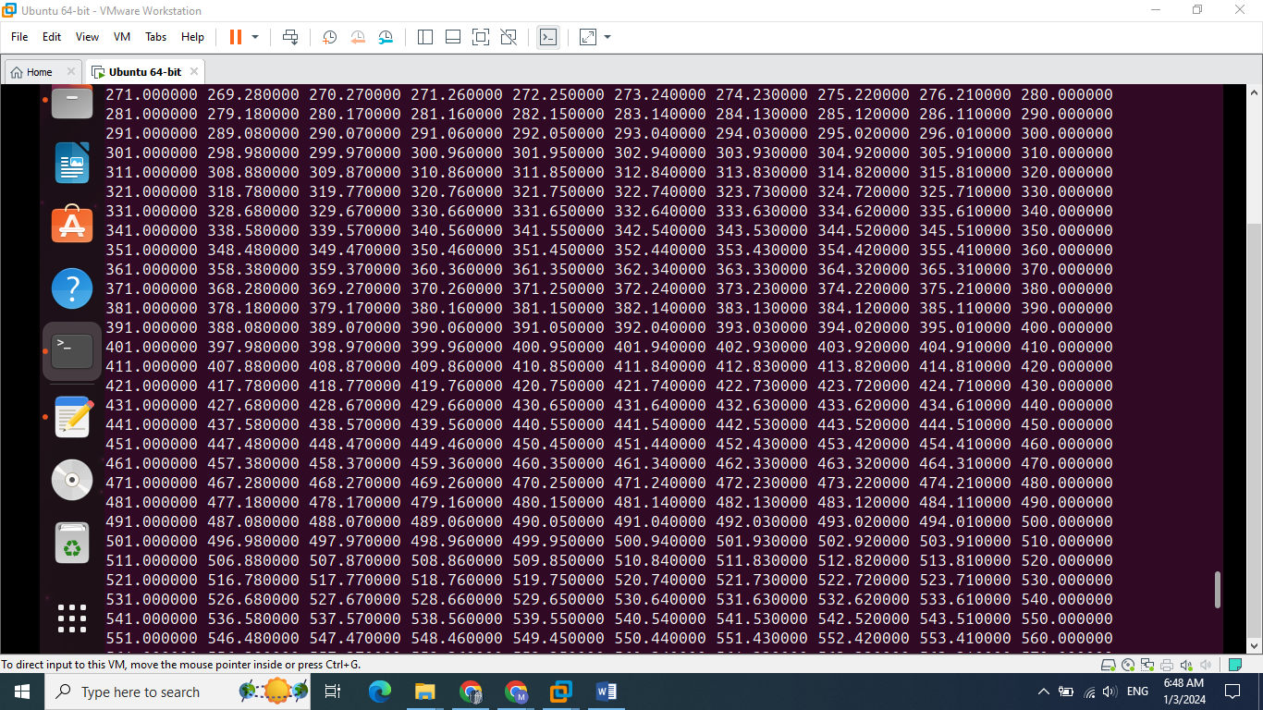

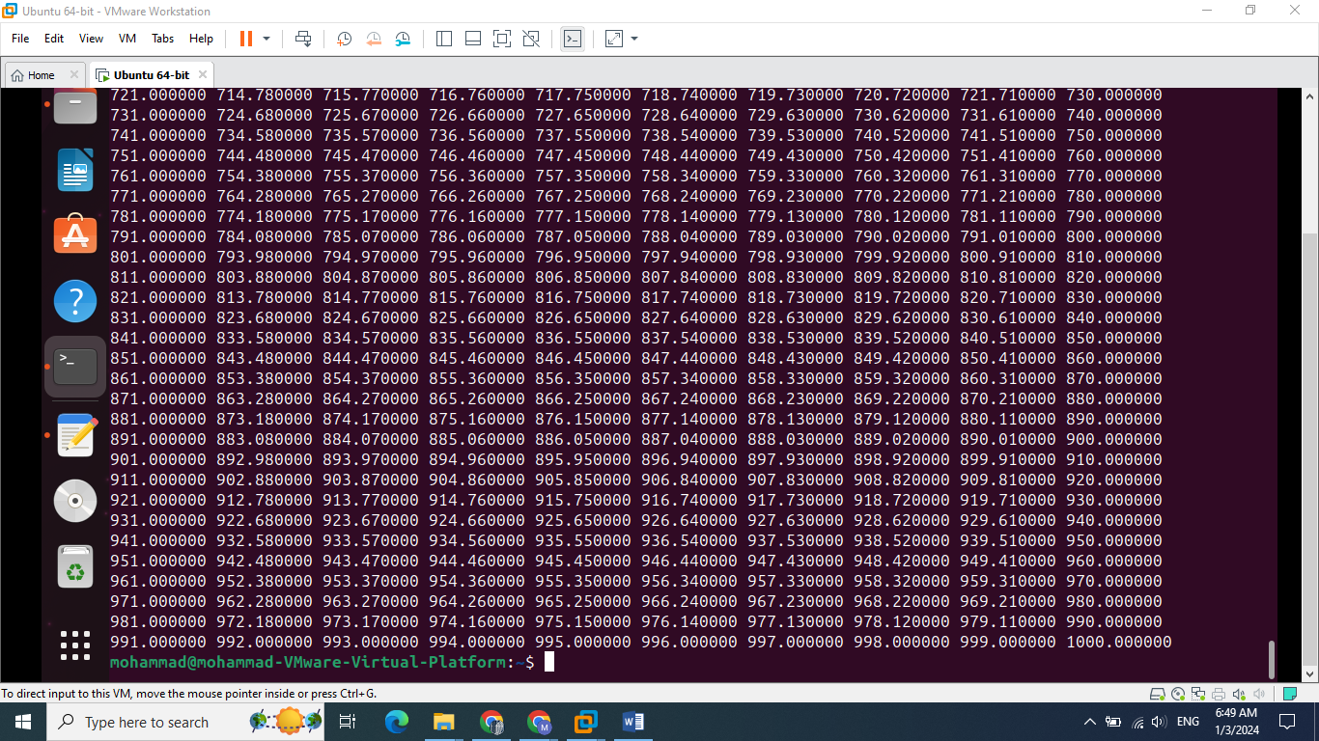

**B) Using pthread library:**

This code employs Pthread to parallelize the application of a filter on an image matrix. It initializes matrices for the original image data and the filtered result, along with a mutex for synchronization. The slave function defines the task distribution among threads, enabling each to handle a specific segment of the image. Threads simultaneously compute the filter on their allocated portions, guarded by a mutex to ensure exclusive access to the shared matrix. The main function creates multiple threads, assigns them sections of the matrix to process, waits for their completion, and then prints both the original and filtered images.

**The Code of pthread:**

#include <pthread.h>

#include <stdio.h>

#define num_threads 6

#define maxsize_row 50

#define maxsize_col 10

double filter_average[3][3]={{0.11,0.11,0.11},{0.11,0.11,0.11},{0.11,0.11,0.11}};

pthread_mutex_t mutex1;

double data[maxsize_row][maxsize_col];

double data_filterd[maxsize_row][maxsize_col];

void fill_Matrix(double m[maxsize_row][maxsize_col])

{

int c=1;

for (int i = 0; i < maxsize_row; i++)

{

for (int j = 0; j < maxsize_col; j++)

{

m[i][j] =c;

c++;

}

}

}

void print_Matrix(double m[maxsize_row][maxsize_col])

{

for(int a=0;a<maxsize_row;a++)

{

//printf("row number %d:",a);

for(int b=0;b<maxsize_col;b++)

printf("%f ",m[a][b]);

printf("\n");

}

}

void *slave(void *tn)

{

long threadN=(long )tn;

int x=(maxsize_row-2)/num_threads;

int rest=(maxsize_row-2) % num_threads;

int start=rest+1;

int low=0,high=0;

if(threadN==0)

{

low=1;

high=start+x;

}

else

{

low=threadN*x+start;

high=low+x;

}

for(int a=low;a<high;a++)

for(int b=1;b<maxsize_col-1;b++)

{

pthread_mutex_lock(&mutex1);

data_filterd[a][b]=(data[a-1][b-1]*filter_average[0][0]) + (data[a-1][b]*filter_average[0][1]) + (data[a-1][b+1]*filter_average[0][2]) + (data[a][b-1]*filter_average[1][0]) +(data[a][b]*filter_average[1][1]) + (data[a][b+1]*filter_average[1][2]) + (data[a+1][b-1]*filter_average[2][0]) + (data[a+1][b]*filter_average[2][1]) + (data[a+1][b+1]*filter_average[2][2]);

pthread_mutex_unlock(&mutex1);

}

}

int main()

{

fill_Matrix(data);

fill_Matrix(data_filterd);

pthread_mutex_init(&mutex1, NULL);

pthread_t thread[num_threads];

for (long i = 0; i < num_threads; i++)

pthread_create(&thread[i], NULL, slave, (void *) i);

for (long i = 0; i < num_threads; i++)

pthread_join(thread[i], NULL);

printf("\n\nthe original image (old image):\n");

print_Matrix(data);

printf("\n\nthe filterd image by average filter (new image):\n");

print_Matrix(data_filterd);

return 0;

}

**Test Cases for Pthread:**

1) Small matrix(10x10):

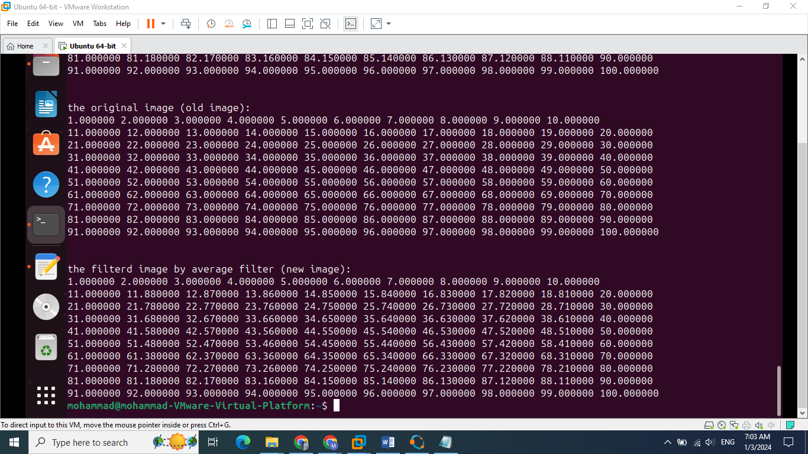

2)Medium matrix(50x10):

Input image:

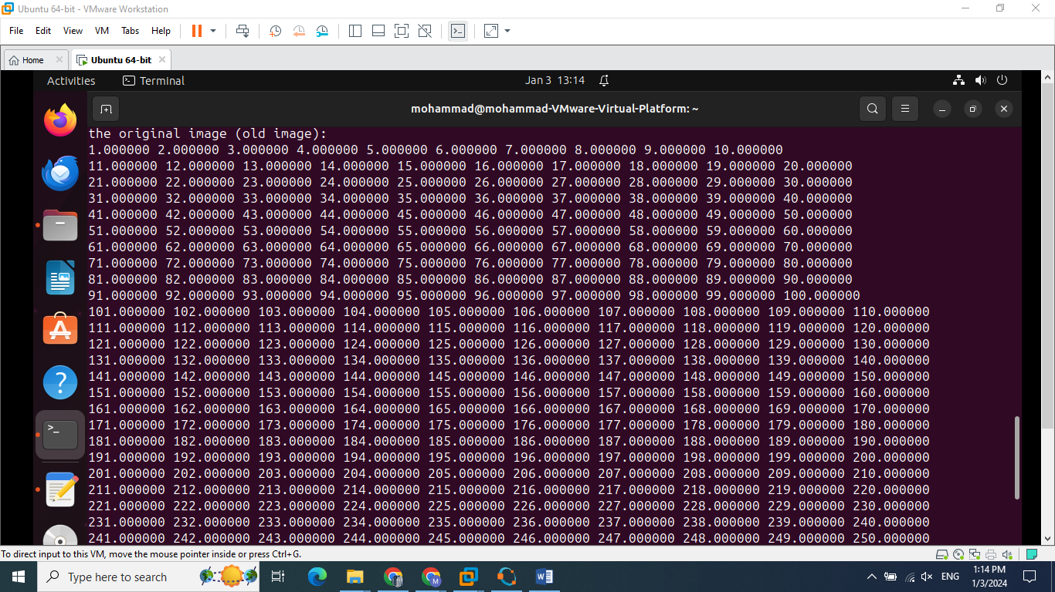

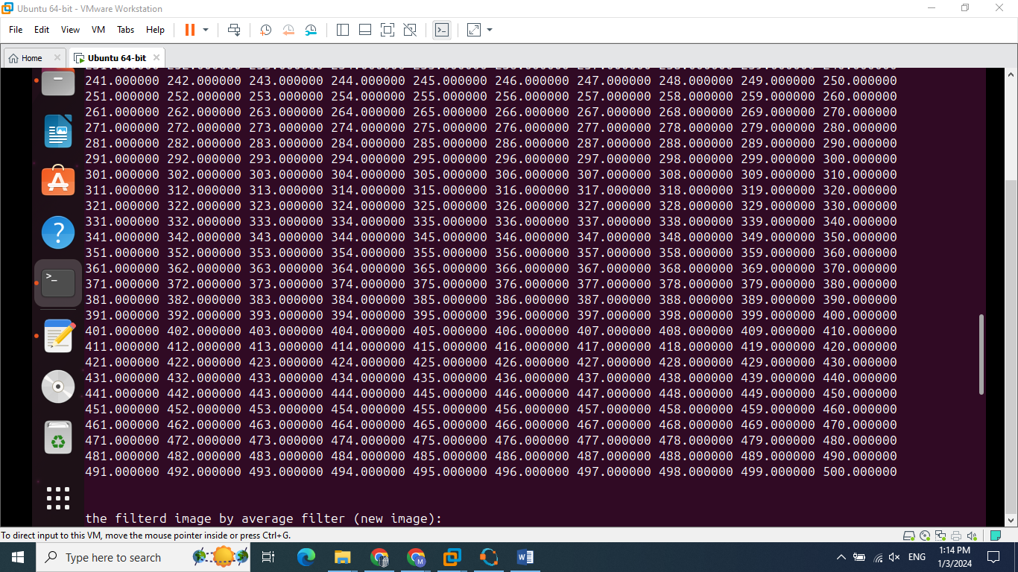

Output image:

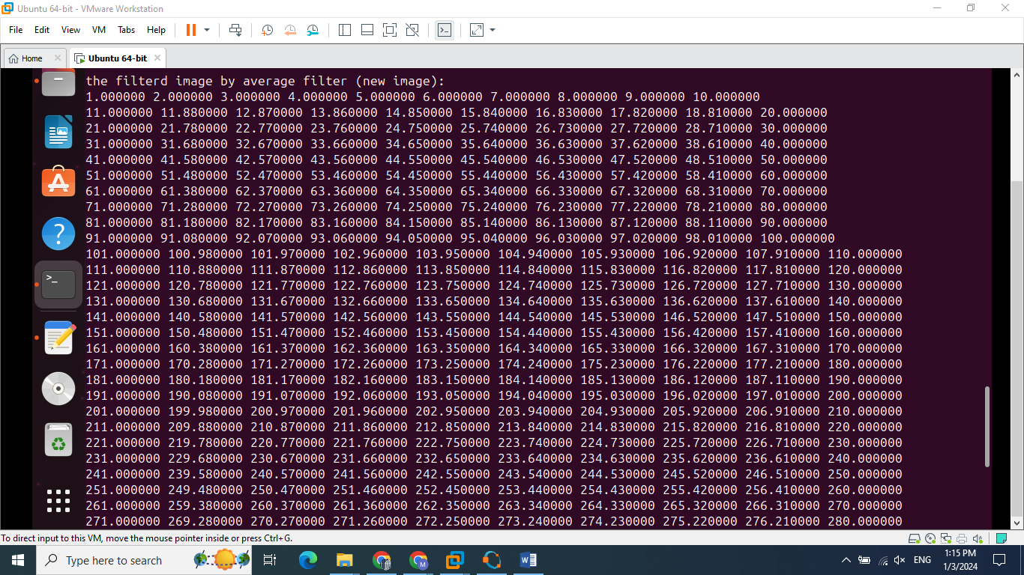

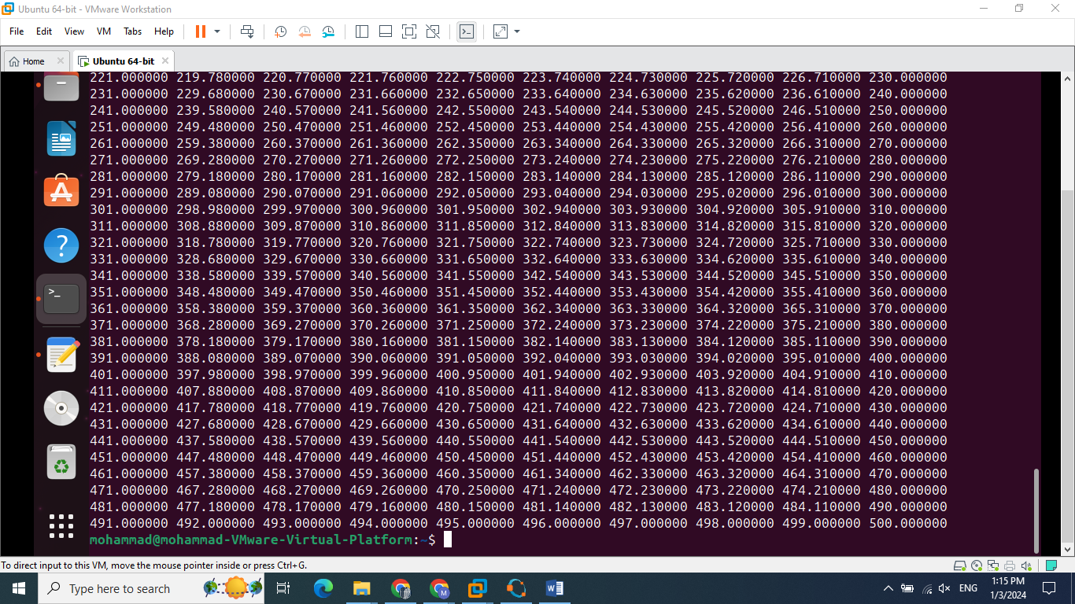

3)Big matrix(100x10):

Input image:

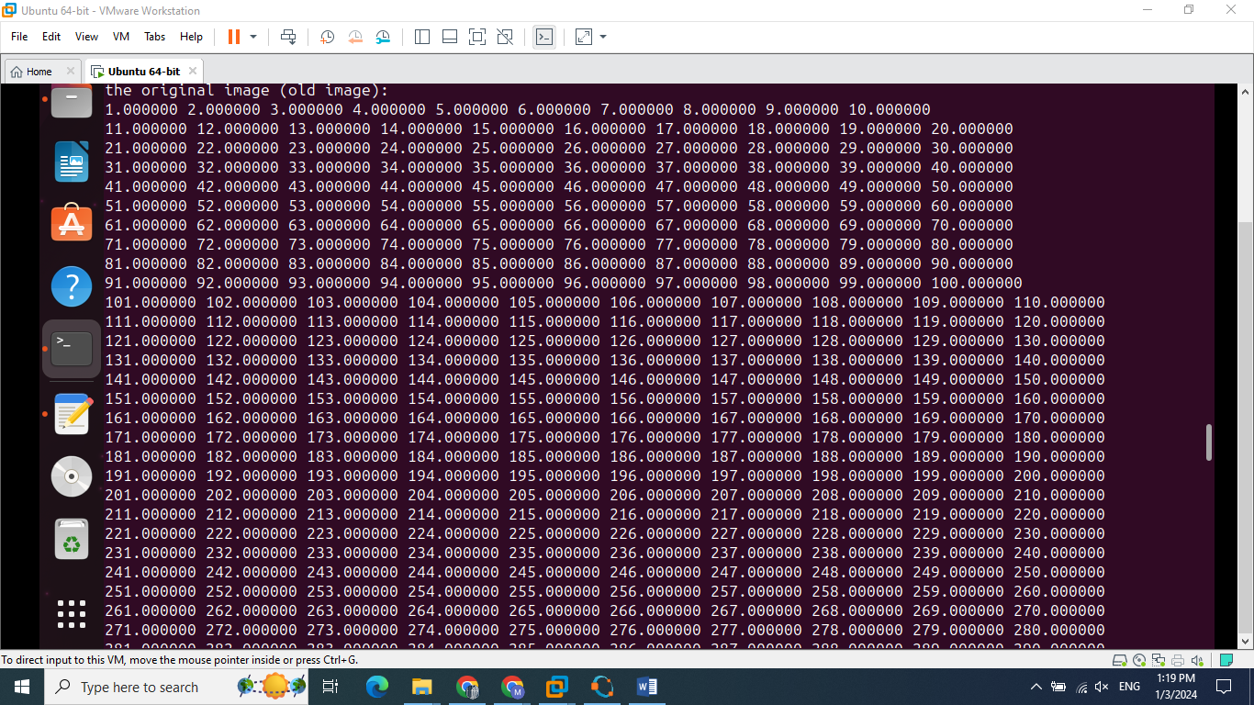

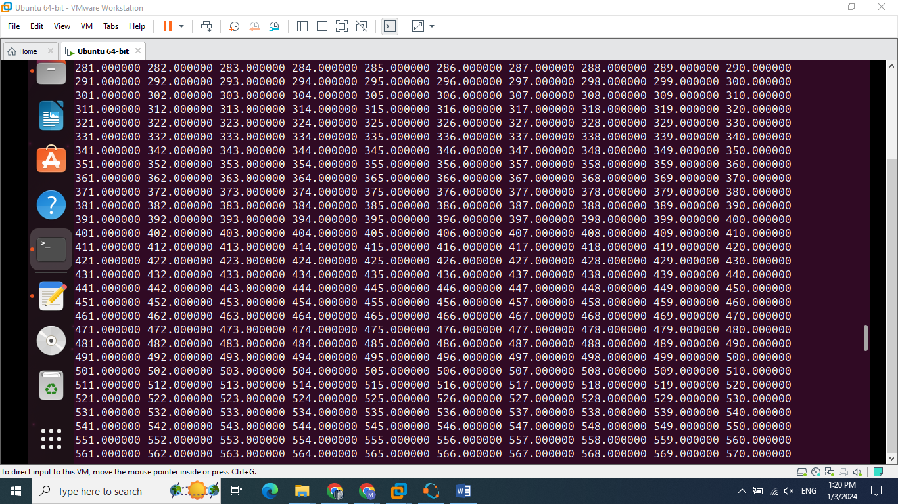

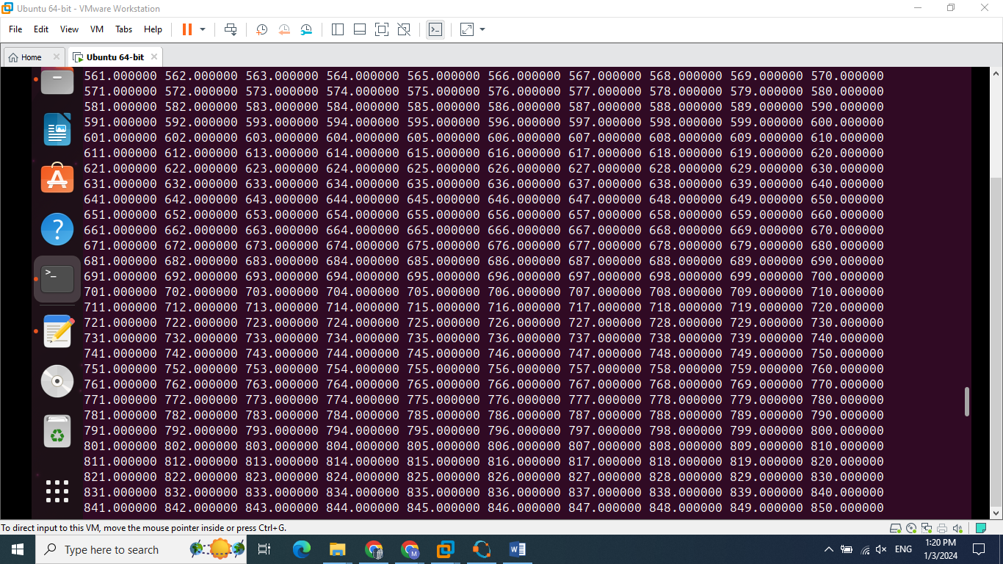

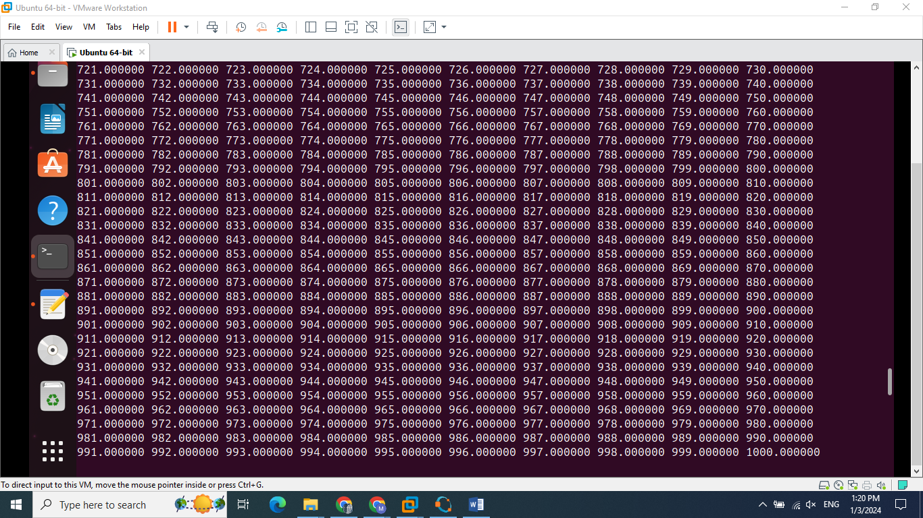

Output image:

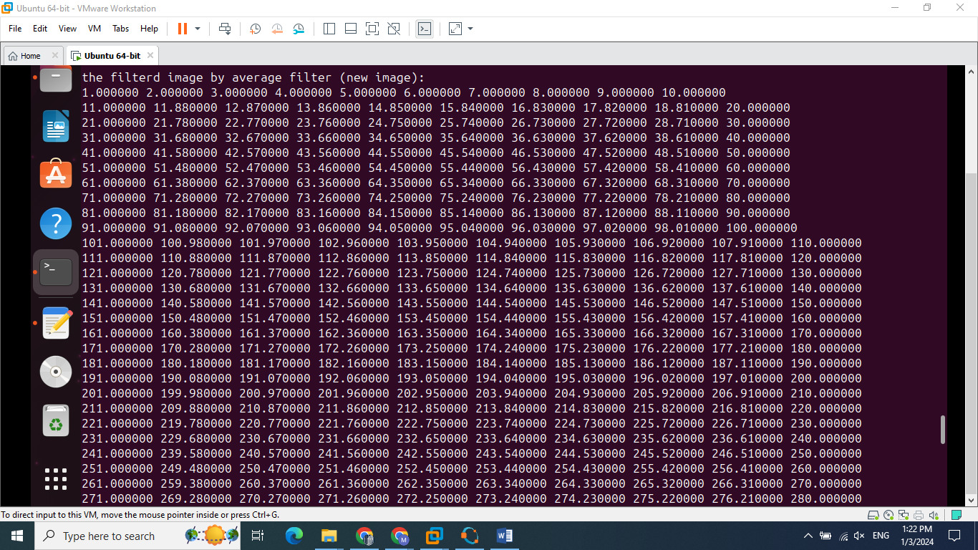

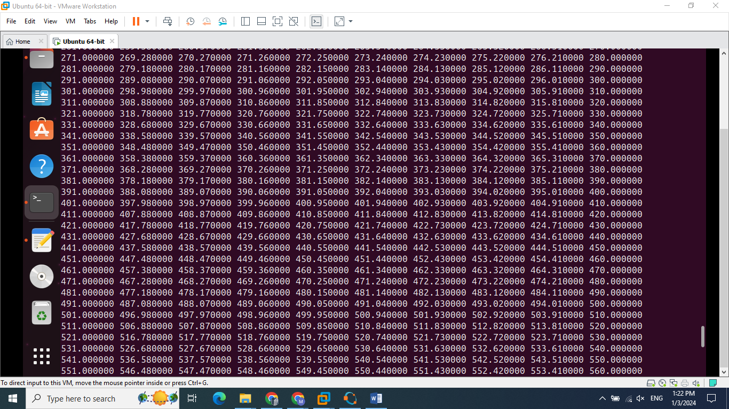

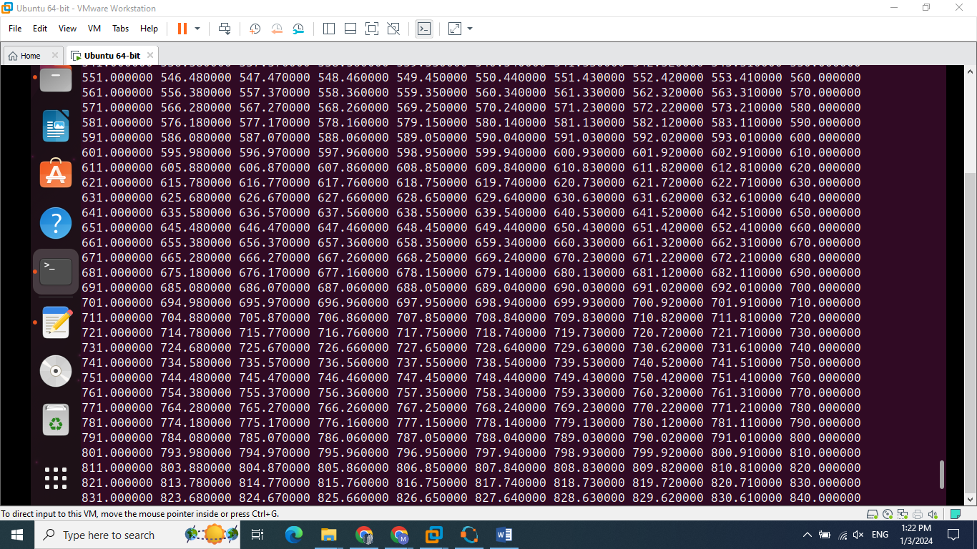

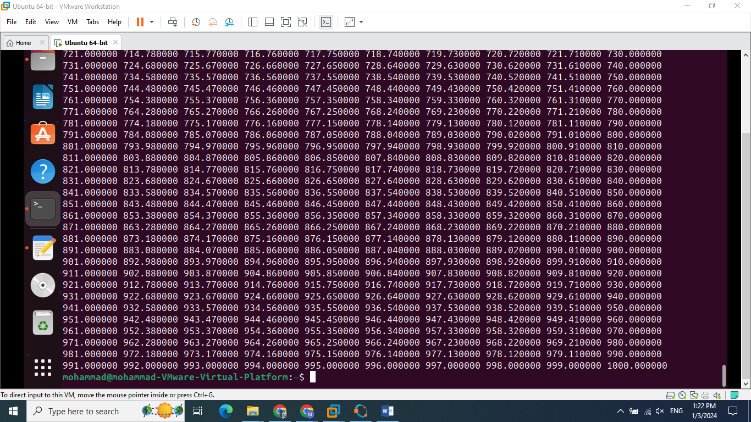

**C)Using the filter on real image:**

1)We will use octave to save pixel values into text file and name it “input.txt”.

2)The program will read pixel values from “input.txt” and apply average filter on the image

3)The program will save the filtered image in text file named “output.txt”.

4)Octave is used to read “output.txt” values and display it as an image.

**Sample:**

Input Image:

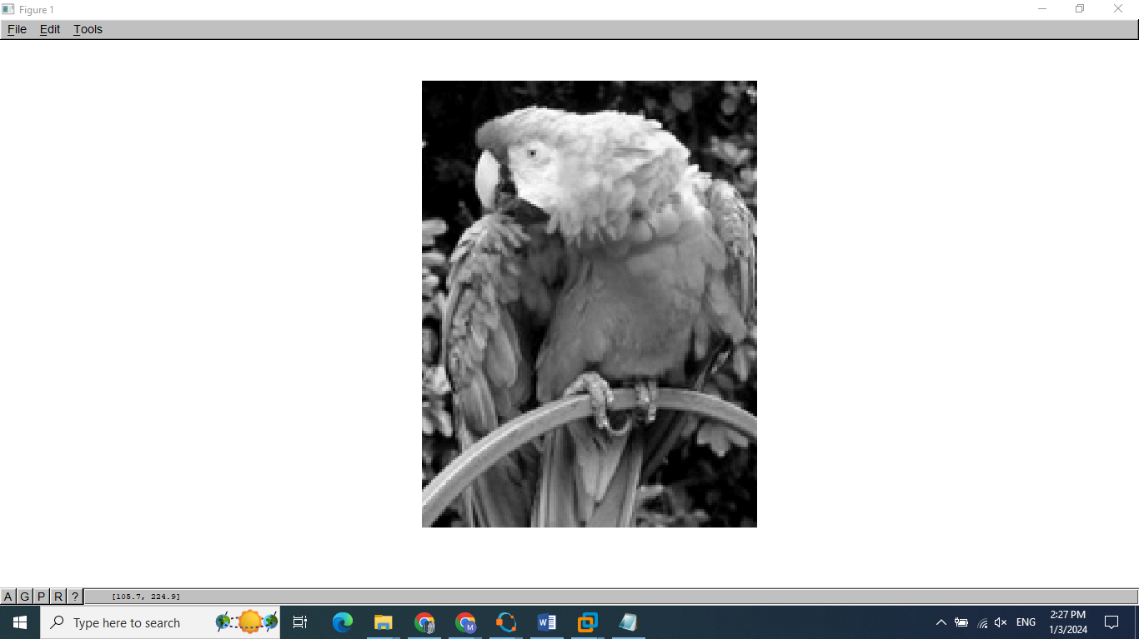

Output Image:

